Department of Computer Science, CUI Lahore
 | Assignment 3
Name: | Section: | Course Title: Semantic Web | Date:
Reg.#: | Instructor: Sana Rizwan | Marks: 10 | Class/Batch:

Question:
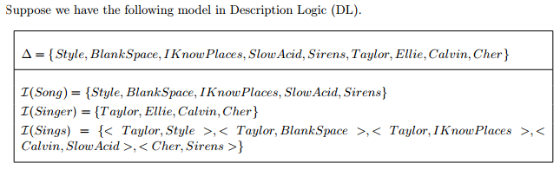
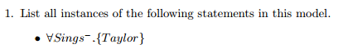
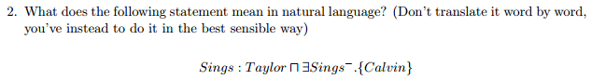

THANKYOU

